
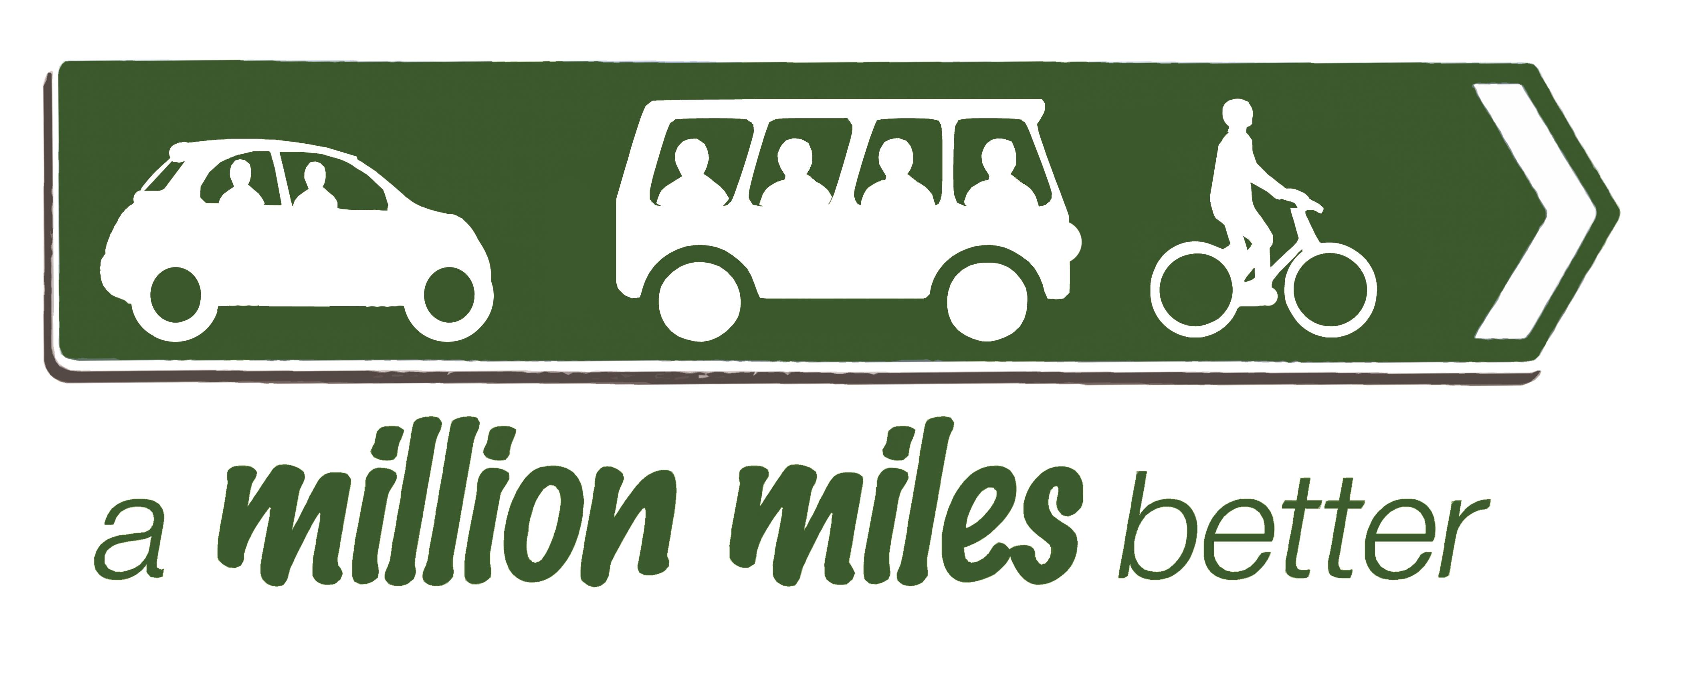
Come and celebrate three great years of achievement
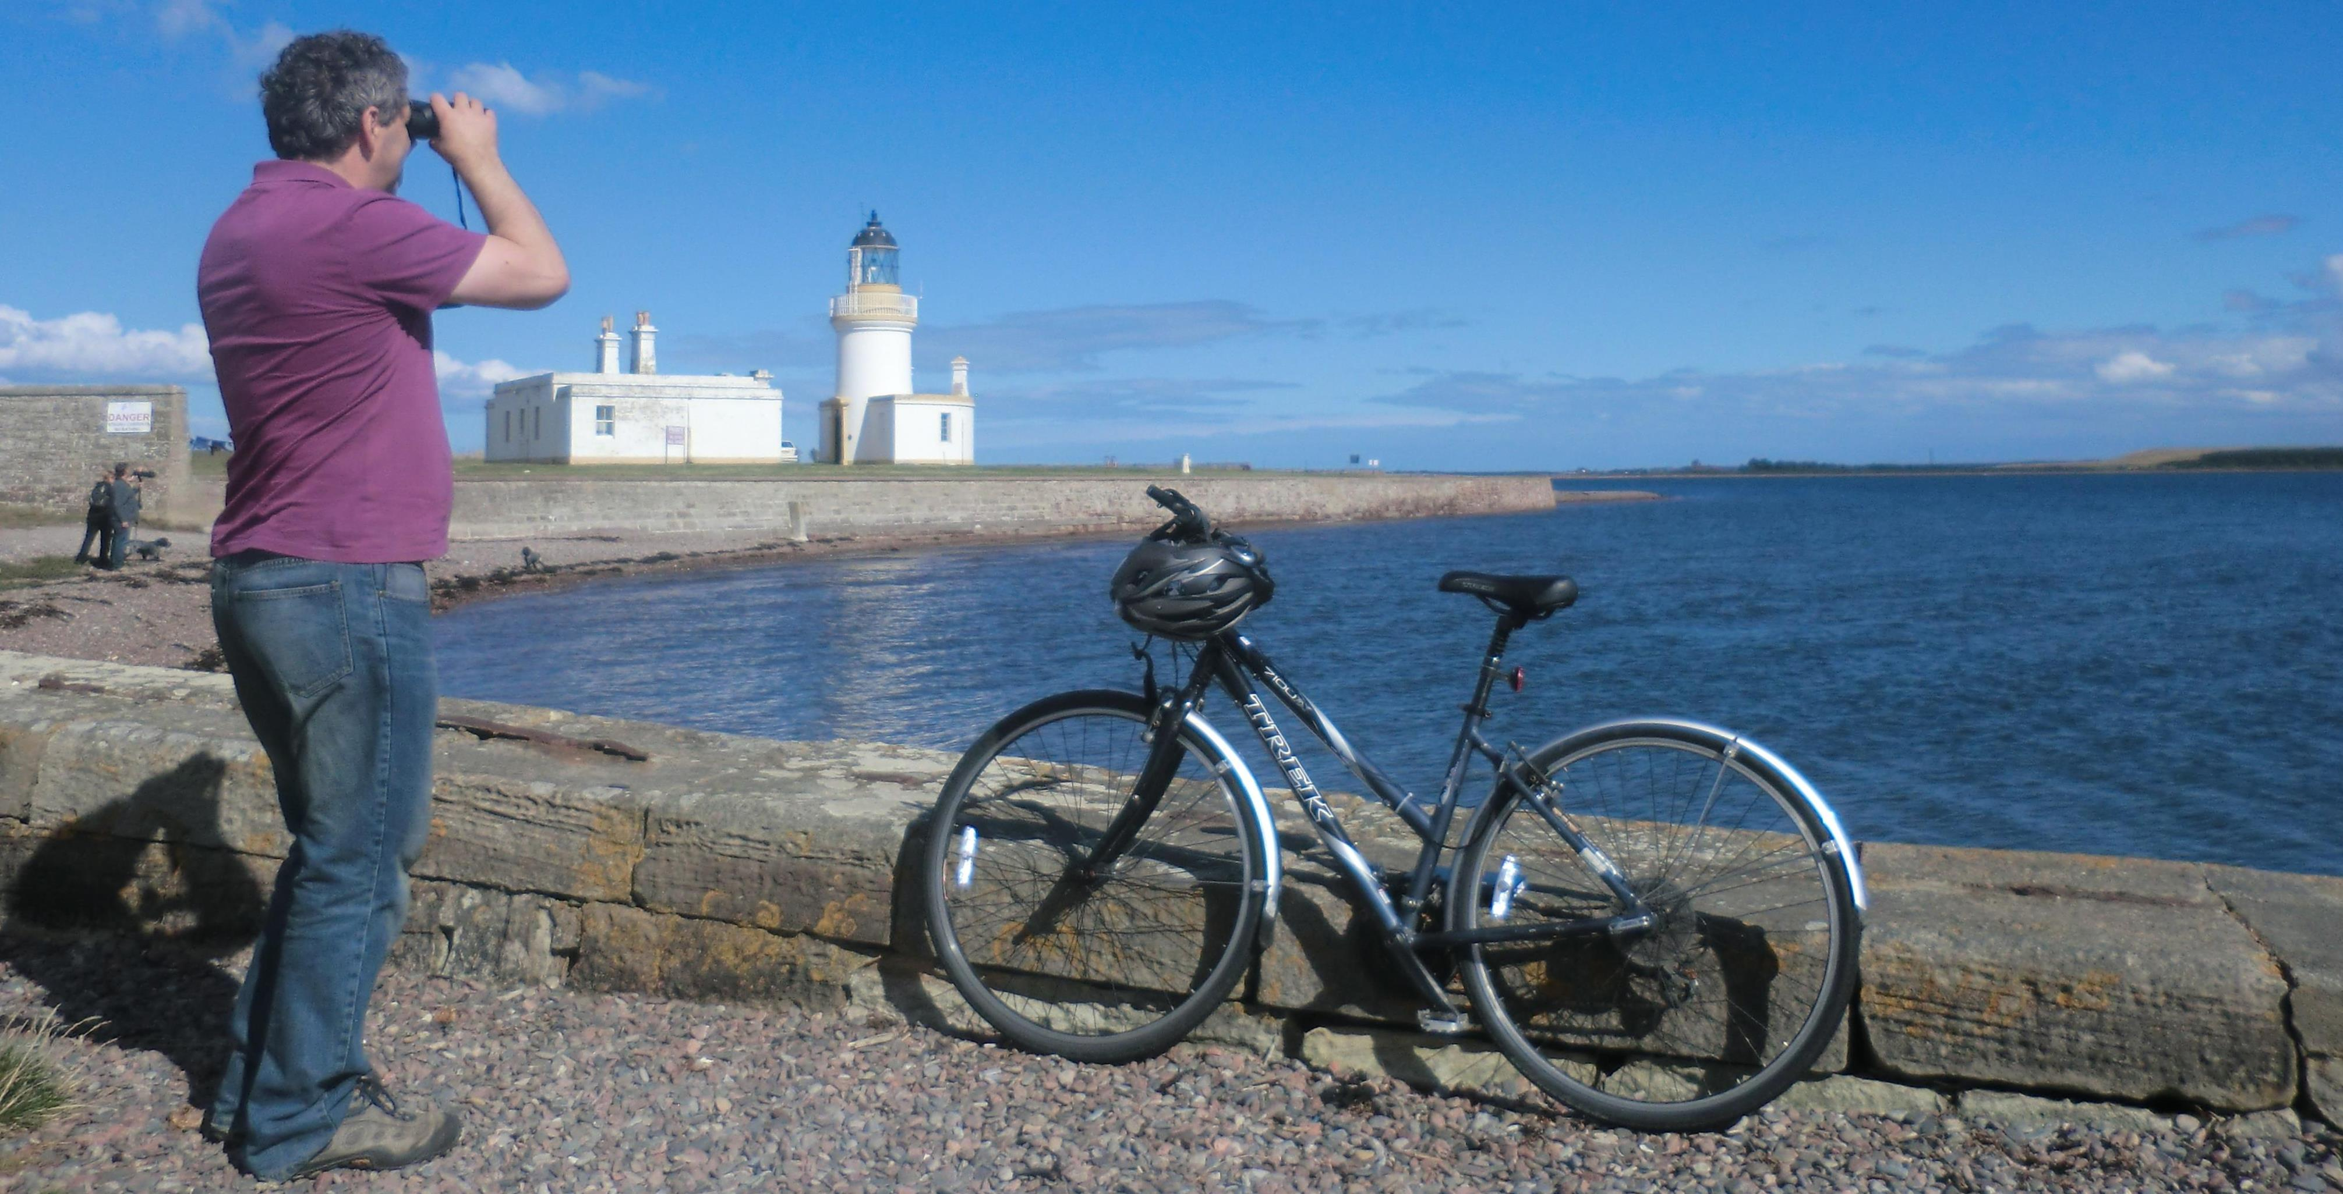
Presentation of project report followed by
BBQ at Glachbeg Croft, North Kessock
May 15th - 5 till 9pm

Please bring food to share or a bottle – and if you can play an instrument,
bring that along too – let’s party!

For more information tel 01349 877822

